

LAb 7

Web Engineering



April 22, 2020

Fatima SEEMAB

291310

**Task 1 Ajax:**

**Code**

<!DOCTYPE html>

<html>

<body>

<h2>Make a table based on JSON data.</h2>

<button id="btn" onclick="loadData()">Fetch Data</button>

<p id="demo"></p>

</body>

<script>

  function loadData()

 { var  xmlhttp, myObj, txt= " ";

  xmlhttp = new XMLHttpRequest();

  xmlhttp.open("GET", "emp_data.json", true);

  xmlhttp.onreadystatechange = function() {

    if (this.readyState == 4 && this.status == 200) {

      myObj = JSON.parse(this.responseText);

     txt += "<table border='1'>"

      txt+="<th>Name</th><th>Designation</th><th>Salary</th><th>Office</th><th>Extension</th><th>Joining Date</th>"

      for (var x=0;x<15;x++) {

        txt += "<tr><td>" + myObj.empolyees[x].name + "</td>";

        txt += "<td>" + myObj.empolyees[x].designation + "</td>";

        txt += "<td>" + myObj.empolyees[x].salary + "</td>";

        txt += "<td>" + myObj.empolyees[x].office + "</td>";

        txt += "<td>" + myObj.empolyees[x].extension + "</td>";

        txt += "<td>" + myObj.empolyees[x].joining_date + "</td></tr>";

      }

      txt += "</table>"

      document.getElementById("demo").innerHTML = txt;

    }

  };

  xmlhttp.send();

}

  </script>

</html>

**Task 1 Screenshot:**

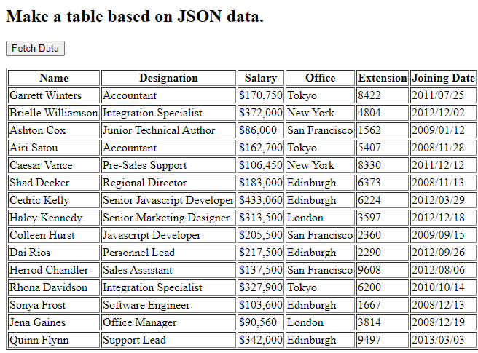

**Task 2 Ajax**

<!DOCTYPE html>

<html>

<style>

table,th,td {

  border : 1px solid black;

  border-collapse: collapse;

}

th,td {

  padding: 5px;

}

</style>

<body>

<button type="button" id='submitButton'>Get my CD collection</button>

<br><br>

<table id="demo"></table>

<div id="error"></div>

<script type="text/javascript">

    function loadDoc() {

        console.log("Load Doc is called");

      var xhttp = new XMLHttpRequest();

      xhttp.onreadystatechange = function() {

        if (this.readyState == 4 && this.status == 200) {

          myFunction(this);

        }

      };

      xhttp.open("GET", "cd_catalog.xml", true);

      xhttp.send();

    }

    function myFunction(xml) {

      console.log("myFunction is called");

      var i;

      var xmlDoc = xml.responseXML;

      var table="<tr><th>Artist</th><th>Title</th><th>Country</th><th>Company</th><th>Price</th><th>Year</th></tr>";

      var x = xmlDoc.getElementsByTagName("CD");

      for (i = 0; i <x.length; i++) {

        table += "<tr><td>" +

        x[i].getElementsByTagName("ARTIST")[0].childNodes[0].nodeValue +

        "</td><td>" +

        x[i].getElementsByTagName("TITLE")[0].childNodes[0].nodeValue +

        "</td><td>" +

        x[i].getElementsByTagName("COUNTRY")[0].childNodes[0].nodeValue +

        "</td><td>" +

        x[i].getElementsByTagName("COMPANY")[0].childNodes[0].nodeValue +

        "</td><td>" +

        x[i].getElementsByTagName("PRICE")[0].childNodes[0].nodeValue +

        "</td><td>" +

        x[i].getElementsByTagName("YEAR")[0].childNodes[0].nodeValue +

        "</td></tr>"

      }

      document.getElementById("demo").innerHTML = table;

    }

</script>

</body>

<script type="text/javascript">

    function loadDoc() {

        console.log("Load Doc is called");

      var xhttp = new XMLHttpRequest();

      xhttp.onreadystatechange = function() {

        if (this.readyState == 4 && this.status == 200) {

          myFunction(this);

        }

      };

      xhttp.open("GET", "cd_catalog.xml", true);

      xhttp.send();

    }

    function myFunction(xml) {

      console.log("myFunction is called");

      var i;

      var xmlDoc = xml.responseXML;

      var table="<tr><th>Artist</th><th>Title</th><th>Country</th><th>Company</th><th>Price</th><th>Year</th></tr>";

      var x = xmlDoc.getElementsByTagName("CD");

      for (i = 0; i <x.length; i++) {

        table += "<tr><td>" +

        x[i].getElementsByTagName("ARTIST")[0].childNodes[0].nodeValue +

        "</td><td>" +

        x[i].getElementsByTagName("TITLE")[0].childNodes[0].nodeValue +

        "</td><td>" +

        x[i].getElementsByTagName("COUNTRY")[0].childNodes[0].nodeValue +

        "</td><td>" +

        x[i].getElementsByTagName("COMPANY")[0].childNodes[0].nodeValue +

        "</td><td>" +

        x[i].getElementsByTagName("PRICE")[0].childNodes[0].nodeValue +

        "</td><td>" +

        x[i].getElementsByTagName("YEAR")[0].childNodes[0].nodeValue +

        "</td></tr>"

      }

      document.getElementById("demo").innerHTML = table;

    }

</script>

</html>

**Task 2 Screenshot**

